*Выполнила: Табольская Е. А. БИСО-03-19*

1. Фото календаря, сделанное дома, с тегом GPS.

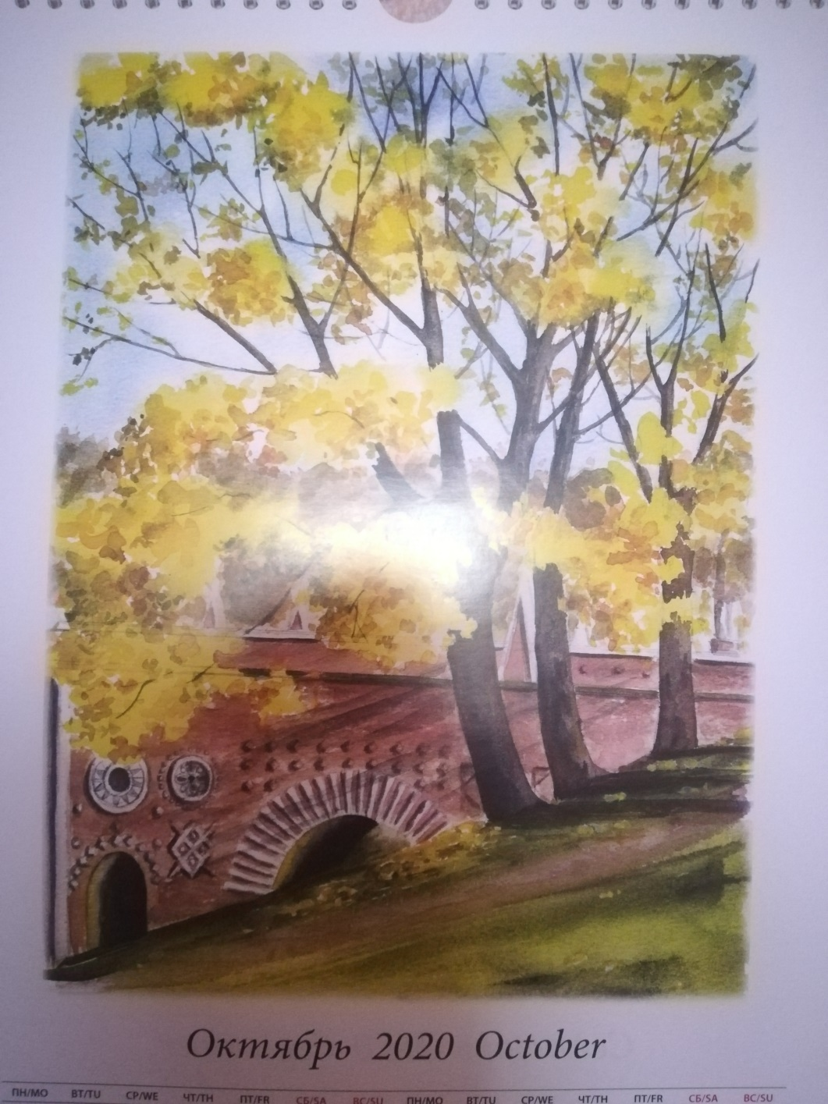

EXIF данные были получены с помощью сервиса exif-viewer.com.

create 2020-10-22T10:33:21+00:00

ApertureValue 227/100

BitsPerSample 8, 8, 8

BrightnessValue 0/1

ColorSpace 1

ComponentsConfiguration 1, 2, 3, 0

Compression 6

Contrast 0

CustomRendered 1

DateTime 2020:10:22 13:26:28

DateTimeDigitized 2020:10:22 13:26:28

DateTimeOriginal 2020:10:22 13:26:28

DeviceSettingDescription 105, 112, 112, 0

DigitalZoomRatio 100/100

DocumentName

ExifImageLength 3968

ExifImageWidth 2976

ExifOffset 278

ExifVersion 48, 50, 49, 48

ExposureBiasValue 0/10

ExposureMode 0

ExposureProgram 2

ExposureTime 70000000/1000000000

FileSource 3

Flash 24

FlashPixVersion 48, 49, 48, 48

FNumber 220/100

FocalLength 3830/1000

FocalLengthIn35mmFilm 26

GainControl 0

ImageDescription mde

ImageLength 3968

ImageWidth 2976

InteroperabilityIndex R98

InteroperabilityOffset 8422

InteroperabilityVersion 48, 49, 48, 48

ISOSpeedRatings 2000

JPEGInterchangeFormat 8582

JPEGInterchangeFormatLength 31496

LightSource 1

Make HUAWEI

MakerNote 35, 35, 35, 35, 10, 0, 0, 0, 26, 199, 51, 1, 8, 128, 1, 0, 0, 0, 0, 0, 0, 0, 0, 0, 0, 0, 0, 0, 1, 0, 0, 0, 34, 7, 0, 0, 255, 255, 255, 255, 255, 255, 255, 255, 255, 255, 255, 255, 255, 255, 255, 255, 255, 255, 255, 255, 255, 255, 255, 255, 255, 255, 255, 255, 255, 255, 255, 255, 255, 255, 255, 255, 255, 255, 255, 255, 255, 255, 255, 255, 255, 255, 255, 255, 255, 255, 255, 255, 255, 255, 255, 255, 255, 255, 255, 255, 255, 255, 255, 255

MeteringMode 5

Model PRA-TL10

Orientation 0

ResolutionUnit 2

Saturation 0

SceneCaptureType 0

SceneType 1

SensingMethod 2

Sharpness 0

ShutterSpeedValue 298973/10000

Software PRA-TL10 8.0.0.375(C10)

SubjectDistanceRange 0

SubSecTime 019923

SubSecTimeDigitized 019923

SubSecTimeOriginal 019923

WhiteBalance 0

XResolution 72/1

YCbCrPositioning 1

YResolution 72/1

modify 2020-10-22T10:33:21+00:00

ApertureValue 227/100

BitsPerSample 8, 8, 8

BrightnessValue 0/1

ColorSpace 1

ComponentsConfiguration 1, 2, 3, 0

Compression 6

Contrast 0

CustomRendered 1

DateTime 2020:10:22 13:26:28

DateTimeDigitized 2020:10:22 13:26:28

DateTimeOriginal 2020:10:22 13:26:28

DeviceSettingDescription 105, 112, 112, 0

DigitalZoomRatio 100/100

DocumentName

ExifImageLength 3968

ExifImageWidth 2976

ExifOffset 278

ExifVersion 48, 50, 49, 48

ExposureBiasValue 0/10

ExposureMode 0

ExposureProgram 2

ExposureTime 70000000/1000000000

FileSource 3

Flash 24

FlashPixVersion 48, 49, 48, 48

FNumber 220/100

FocalLength 3830/1000

FocalLengthIn35mmFilm 26

GainControl 0

ImageDescription mde

ImageLength 3968

ImageWidth 2976

InteroperabilityIndex R98

InteroperabilityOffset 8422

InteroperabilityVersion 48, 49, 48, 48

ISOSpeedRatings 2000

JPEGInterchangeFormat 8582

JPEGInterchangeFormatLength 31496

LightSource 1

Make HUAWEI

MakerNote 35, 35, 35, 35, 10, 0, 0, 0, 26, 199, 51, 1, 8, 128, 1, 0, 0, 0, 0, 0, 0, 0, 0, 0, 0, 0, 0, 0, 1, 0, 0, 0, 34, 7, 0, 0, 255, 255, 255, 255, 255, 255, 255, 255, 255, 255, 255, 255, 255, 255, 255, 255, 255, 255, 255, 255, 255, 255, 255, 255, 255, 255, 255, 255, 255, 255, 255, 255, 255, 255, 255, 255, 255, 255, 255, 255, 255, 255, 255, 255, 255, 255, 255, 255, 255, 255, 255, 255, 255, 255, 255, 255, 255, 255, 255, 255, 255, 255, 255, 255

MeteringMode 5

Model PRA-TL10

Orientation 0

ResolutionUnit 2

Saturation 0

SceneCaptureType 0

SceneType 1

SensingMethod 2

Sharpness 0

ShutterSpeedValue 298973/10000

Software PRA-TL10 8.0.0.375(C10)

SubjectDistanceRange 0

SubSecTime 019923

SubSecTimeDigitized 019923

SubSecTimeOriginal 019923

WhiteBalance 0

XResolution 72/1

YCbCrPositioning 1

YResolution 72/1

colorspace 2

ApertureValue 227/100

BitsPerSample 8, 8, 8

BrightnessValue 0/1

ColorSpace 1

ComponentsConfiguration 1, 2, 3, 0

Compression 6

Contrast 0

CustomRendered 1

DateTime 2020:10:22 13:26:28

DateTimeDigitized 2020:10:22 13:26:28

DateTimeOriginal 2020:10:22 13:26:28

DeviceSettingDescription 105, 112, 112, 0

DigitalZoomRatio 100/100

DocumentName

ExifImageLength 3968

ExifImageWidth 2976

ExifOffset 278

ExifVersion 48, 50, 49, 48

ExposureBiasValue 0/10

ExposureMode 0

ExposureProgram 2

ExposureTime 70000000/1000000000

FileSource 3

Flash 24

FlashPixVersion 48, 49, 48, 48

FNumber 220/100

FocalLength 3830/1000

FocalLengthIn35mmFilm 26

GainControl 0

ImageDescription mde

ImageLength 3968

ImageWidth 2976

InteroperabilityIndex R98

InteroperabilityOffset 8422

InteroperabilityVersion 48, 49, 48, 48

ISOSpeedRatings 2000

JPEGInterchangeFormat 8582

JPEGInterchangeFormatLength 31496

LightSource 1

Make HUAWEI

MakerNote 35, 35, 35, 35, 10, 0, 0, 0, 26, 199, 51, 1, 8, 128, 1, 0, 0, 0, 0, 0, 0, 0, 0, 0, 0, 0, 0, 0, 1, 0, 0, 0, 34, 7, 0, 0, 255, 255, 255, 255, 255, 255, 255, 255, 255, 255, 255, 255, 255, 255, 255, 255, 255, 255, 255, 255, 255, 255, 255, 255, 255, 255, 255, 255, 255, 255, 255, 255, 255, 255, 255, 255, 255, 255, 255, 255, 255, 255, 255, 255, 255, 255, 255, 255, 255, 255, 255, 255, 255, 255, 255, 255, 255, 255, 255, 255, 255, 255, 255, 255

MeteringMode 5

Model PRA-TL10

Orientation 0

ResolutionUnit 2

Saturation 0

SceneCaptureType 0

SceneType 1

SensingMethod 2

Sharpness 0

ShutterSpeedValue 298973/10000

Software PRA-TL10 8.0.0.375(C10)

SubjectDistanceRange 0

SubSecTime 019923

SubSecTimeDigitized 019923

SubSecTimeOriginal 019923

WhiteBalance 0

XResolution 72/1

YCbCrPositioning 1

YResolution 72/1

sampling-factor 2x2,1x1,1x1

ApertureValue 227/100

BitsPerSample 8, 8, 8

BrightnessValue 0/1

ColorSpace 1

ComponentsConfiguration 1, 2, 3, 0

Compression 6

Contrast 0

CustomRendered 1

DateTime 2020:10:22 13:26:28

DateTimeDigitized 2020:10:22 13:26:28

DateTimeOriginal 2020:10:22 13:26:28

DeviceSettingDescription 105, 112, 112, 0

DigitalZoomRatio 100/100

DocumentName

ExifImageLength 3968

ExifImageWidth 2976

ExifOffset 278

ExifVersion 48, 50, 49, 48

ExposureBiasValue 0/10

ExposureMode 0

ExposureProgram 2

ExposureTime 70000000/1000000000

FileSource 3

Flash 24

FlashPixVersion 48, 49, 48, 48

FNumber 220/100

FocalLength 3830/1000

FocalLengthIn35mmFilm 26

GainControl 0

ImageDescription mde

ImageLength 3968

ImageWidth 2976

InteroperabilityIndex R98

InteroperabilityOffset 8422

InteroperabilityVersion 48, 49, 48, 48

ISOSpeedRatings 2000

JPEGInterchangeFormat 8582

JPEGInterchangeFormatLength 31496

LightSource 1

Make HUAWEI

MakerNote 35, 35, 35, 35, 10, 0, 0, 0, 26, 199, 51, 1, 8, 128, 1, 0, 0, 0, 0, 0, 0, 0, 0, 0, 0, 0, 0, 0, 1, 0, 0, 0, 34, 7, 0, 0, 255, 255, 255, 255, 255, 255, 255, 255, 255, 255, 255, 255, 255, 255, 255, 255, 255, 255, 255, 255, 255, 255, 255, 255, 255, 255, 255, 255, 255, 255, 255, 255, 255, 255, 255, 255, 255, 255, 255, 255, 255, 255, 255, 255, 255, 255, 255, 255, 255, 255, 255, 255, 255, 255, 255, 255, 255, 255, 255, 255, 255, 255, 255, 255

MeteringMode 5

Model PRA-TL10

Orientation 0

ResolutionUnit 2

Saturation 0

SceneCaptureType 0

SceneType 1

SensingMethod 2

Sharpness 0

ShutterSpeedValue 298973/10000

Software PRA-TL10 8.0.0.375(C10)

SubjectDistanceRange 0

SubSecTime 019923

SubSecTimeDigitized 019923

SubSecTimeOriginal 019923

WhiteBalance 0

XResolution 72/1

YCbCrPositioning 1

YResolution 72/1

2. FOCA

Сайт: en.wikipedia.org (01.11.2020)

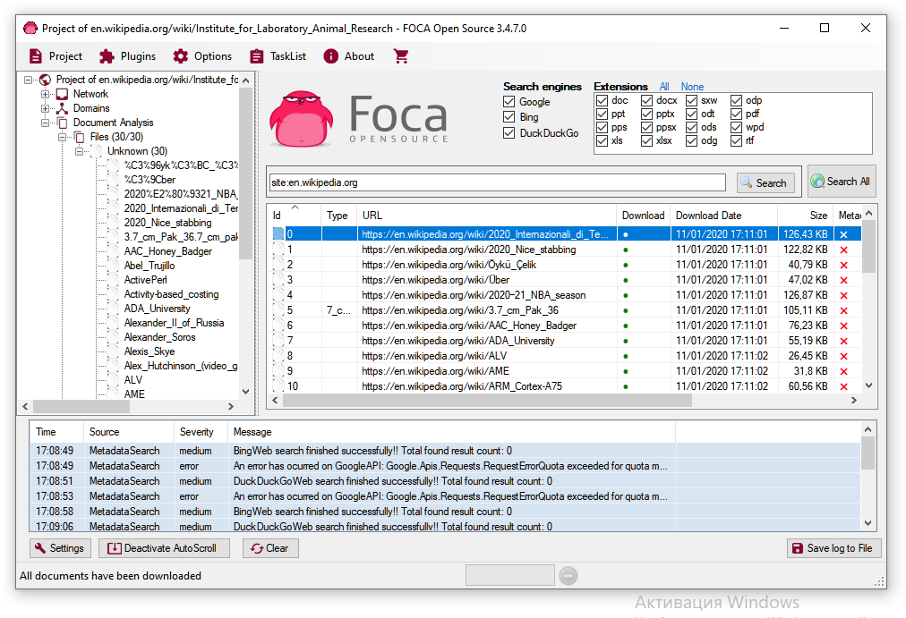

Нашлось 30 файлов:

https://en.wikipedia.org/wiki/2020_Internazionali_di_Tennis_Città_di_Parma_–_Singles

https://en.wikipedia.org/wiki/2020_Nice_stabbing

https://en.wikipedia.org/wiki/Öykü_Çelik

https://en.wikipedia.org/wiki/Über

https://en.wikipedia.org/wiki/2020–21_NBA_season

https://en.wikipedia.org/wiki/3.7_cm_Pak_36

https://en.wikipedia.org/wiki/AAC_Honey_Badger

https://en.wikipedia.org/wiki/ADA_University

https://en.wikipedia.org/wiki/ALV

https://en.wikipedia.org/wiki/AME

https://en.wikipedia.org/wiki/ARM_Cortex-A75

https://en.wikipedia.org/wiki/Abel_Trujillo

https://en.wikipedia.org/wiki/ActivePerl

https://en.wikipedia.org/wiki/Activity-based_costing

https://en.wikipedia.org/wiki/Alex_Hutchinson_(video_game_director)

https://en.wikipedia.org/wiki/Alexander_II_of_Russia

https://en.wikipedia.org/wiki/Alexander_Soros

https://en.wikipedia.org/wiki/Alexis_Skye

https://en.wikipedia.org/wiki/Analytic_language

https://en.wikipedia.org/wiki/Antonio_Lafreri

https://en.wikipedia.org/wiki/Any.do

https://en.wikipedia.org/wiki/Any_Port_in_a_Storm

https://en.wikipedia.org/wiki/Arctic

https://en.wikipedia.org/wiki/Arid

https://en.wikipedia.org/wiki/Arion_(band)

https://en.wikipedia.org/wiki/Arkhipo-Osipovka

https://en.wikipedia.org/wiki/Artificial_leather

https://en.wikipedia.org/wiki/As_Above,_So_Below_(film)

https://en.wikipedia.org/wiki/Ashlynn_Yennie

https://en.wikipedia.org/wiki/Asset

3. CCLEANER.

Проверка реестра: 520 ошибок.

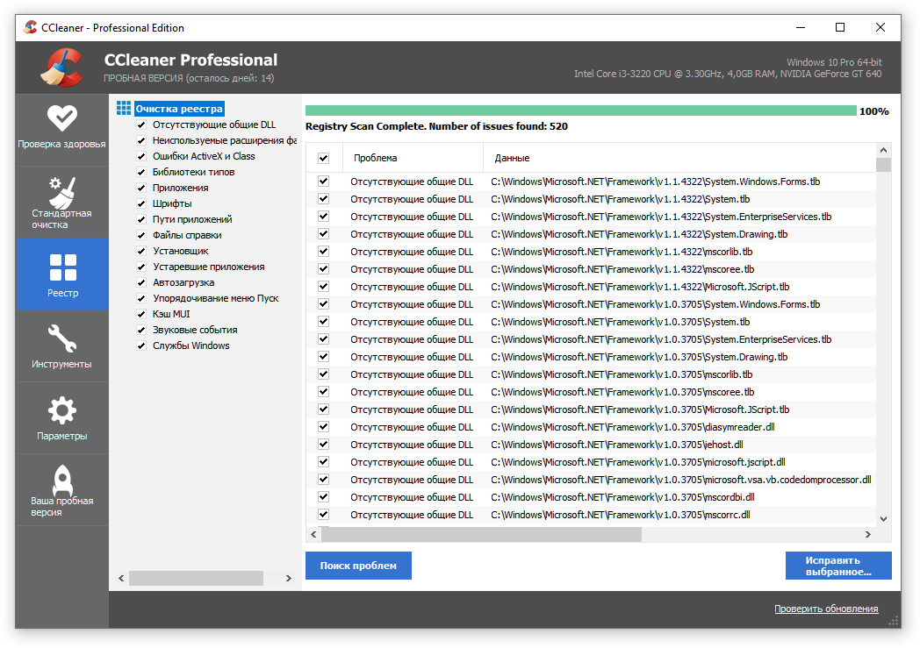

Анализ системы: можно очистить 45,6 Мб.

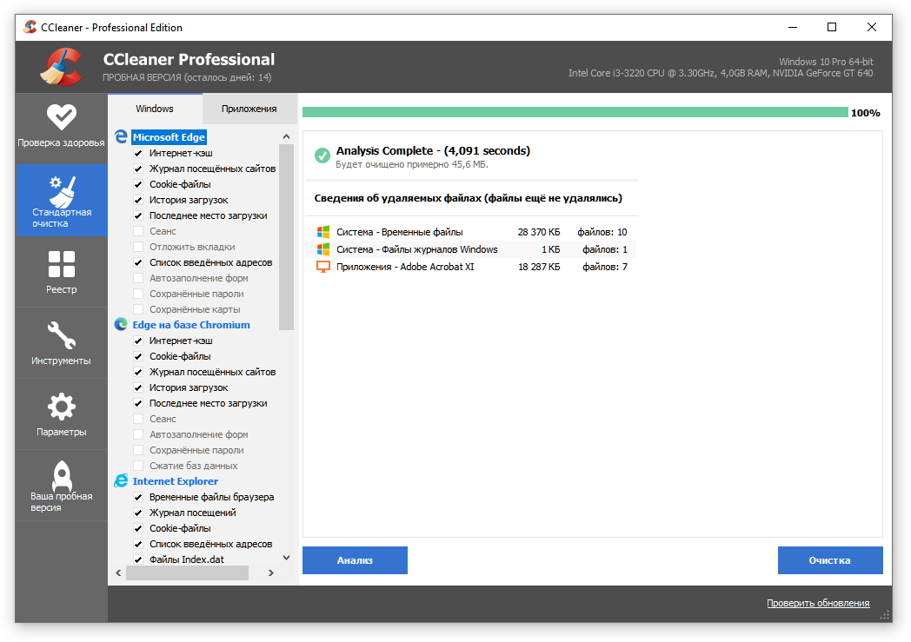

4. RSTUDIO.

Был создан файл: Новый тестовый документ.txt.

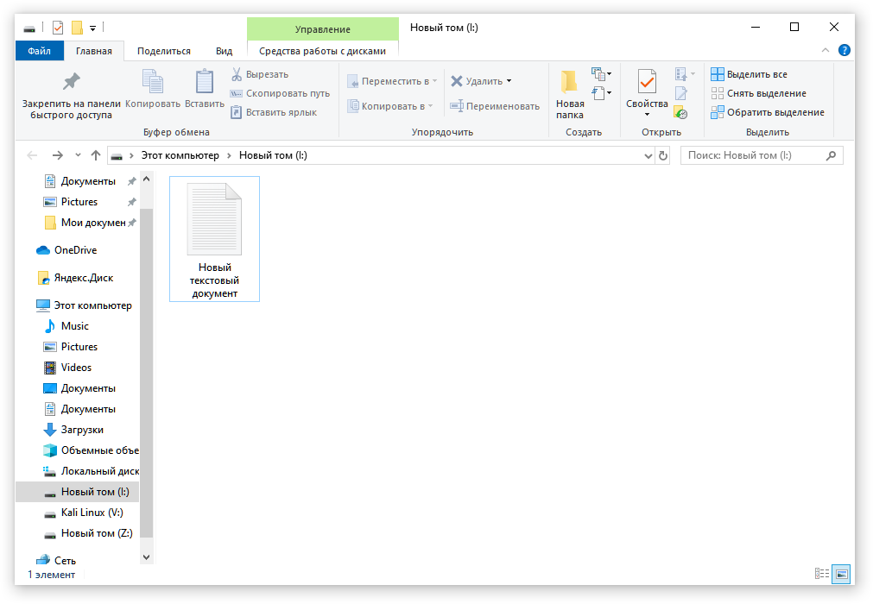

Затем он был удалён и снова восстановлен.

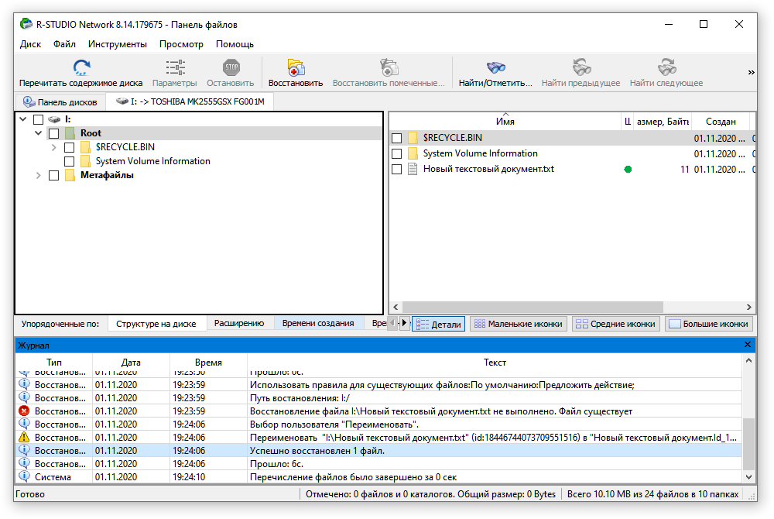

Файл был удален через CCleaner.

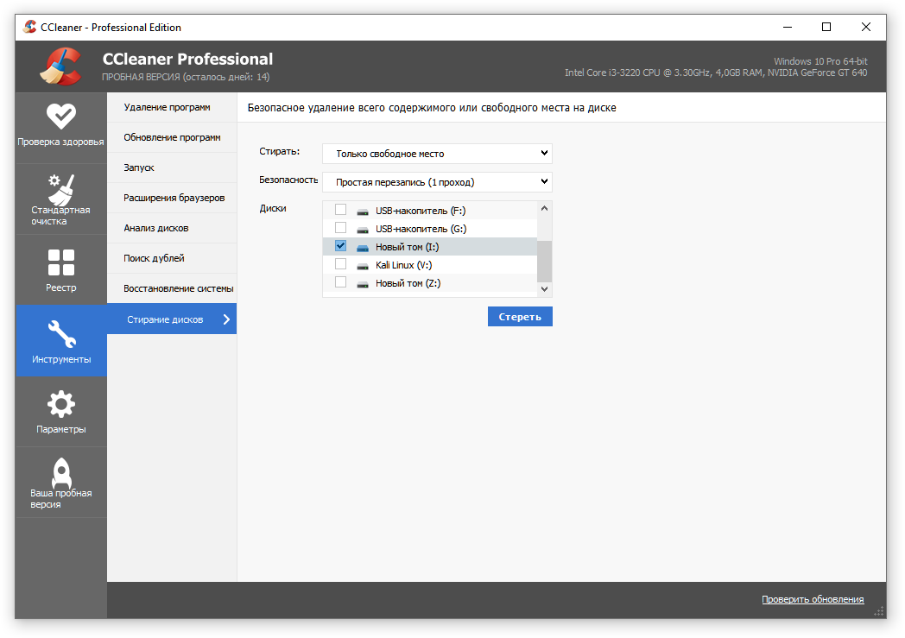

R-Studio не нашла файл при попытке восстановить его.

